2,3,4,5,6
Sd, variance, coefficient
- Sd- mean
Variance
To find a sd we need mean and variance
Sd- it is the variability or spreadness between your data points from mean
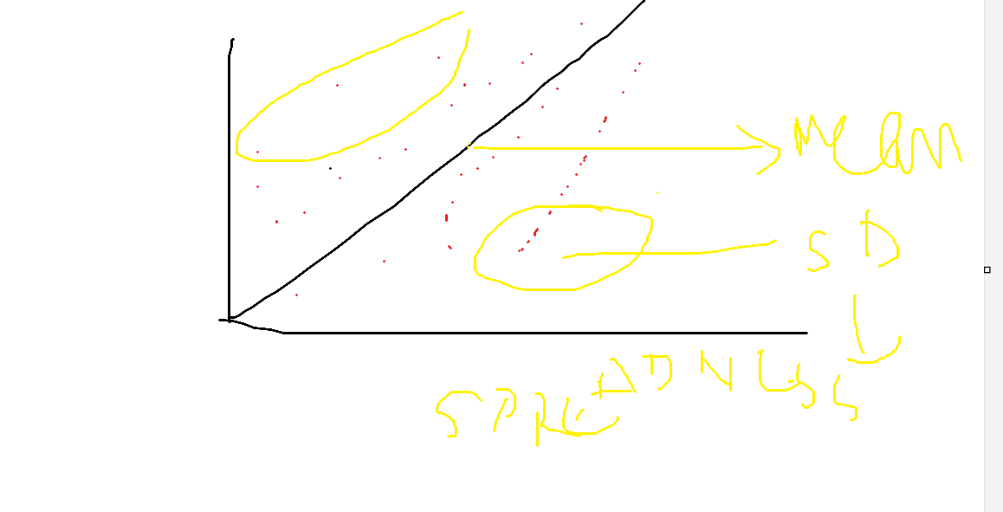
u = mean
population mean
=2+3+4+5+6/5
=20/5=4
Sd
X deviation deviation square
2 (x-u)=2-4=-2 2*2=4
3 3-4=-11 1
4 4-4=0 0
5 5-4=1 1
6 6-4=2 4
10(deviation squre )
Variance
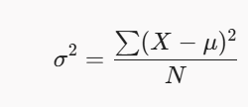10/4=2.5
Sd=root of 2.5 = 1.4
Coeffiecnt of variance
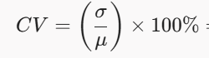
1.4/4*100=1.4/4=0.35=35%

